**Survival Rate**

Graph “Survival Rate During Treatment” show that the mice that were given Capomulin and Ramicane had a higher survival rate versus the mice that were treated with the other drugs, including the placebo. The survival rate of the two aforementioned drugs is 80% to 84% after the 45 day trial. The rest of the drugs have a significant lower survival rate: between 27% and 56% after the 45 days.

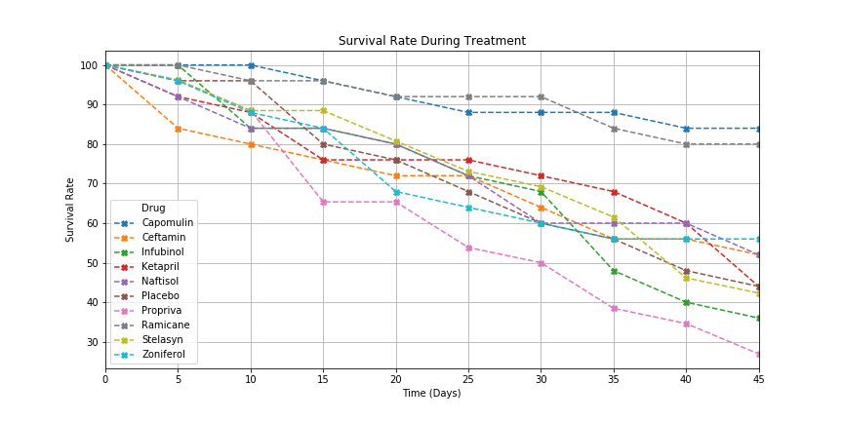

**Metastatic Spread**

From the following chart, we can see that the mice had a particularly strong type of tumor/cancer, all tumors spreaded regardless of the drug given to the mice. Again, the drugs Capomulin and Ramicane showed a slower metastatic spread, but not a signifcant difference against Stelasyn or Infunibol.

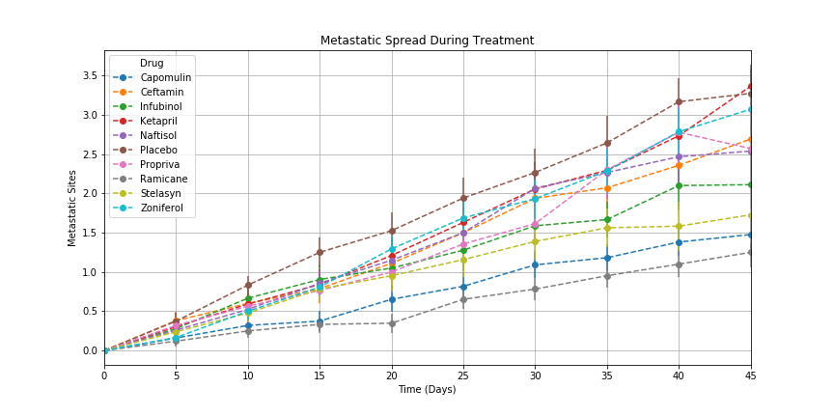

**Tumor response to Treatment**

This graph shows that out of the 10 different drugs used in the trial (including a placebo), only 2 of them help reduce the size of the tumor in mice: Ramicane and Capomulin. The mice that were treated with the other drugs experienced a similar growth rate in the tumor’s volume.

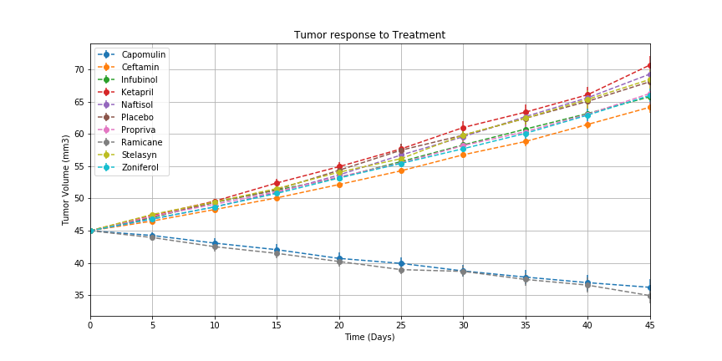

The following graph help visualize the impact in the tumor’s volume percentage change after 45 days. Drugs Ramicane and Capomulin reduced the tumor’s volume by 22% and 19.5%, respectively, by the end of the trial. The rest of the drugs hover around between 42% and 58% *increase* in the tumor’s size during the same time frame.

